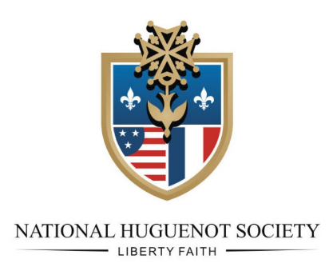

NHS 90TH ANNUAL CONGRESS
INFORMATION
Jacksonville, Florida
October 2 – 4, 2025

Thursday, October 2, 2025

7:30 a.m. Breakfast on your own, complimentary buffet breakfast included for two persons per room (excluding cook to order items)

8:30 a.m. on your own, including lunch

9:00 – 9:30 a.m. Registration in front of Deerwood I and II meeting rooms

1:00 – 6 p.m. Board of General Officers’ Meeting – Deerwood I and II meeting rooms

7:00 p.m. Begin gathering in lobby to car pool to dinner

7:30 p.m. Dinner and non-alcoholic beverages at Terra Gaucha Steakhouse, 4483 Southside Boulevard, Jacksonville, FL 32216, individuals responsible for own alcoholic drinks

Friday, October 3, 2025

7:30 a.m. Breakfast on your own, complimentary buffet breakfast included for two persons per room (excluding cook to order items)

9:00 – 9:30 a.m. Registration in front of Deerwood I and II meeting rooms

10:00 a.m. Leave for Fort Caroline National Memorial and Timucuan Ecological and Historic Preserve, 12713 Fort Caroline Road, Jacksonville, FL 32225 – alternative visit will be Beaches Museum and History Museum, 381 Beach Boulevard, Jacksonville Beach, FL 32250

1:00 p.m. +/- Dutch treat lunch near Fort Caroline at Billy Jack’s BBQ, 9560 Heckscher Drive, Jacksonville, FL 32226 or Beaches Museum at Beachside Seafood, 120 3rd St S, Jacksonville Beach, FL 32250

6:00 p.m. Cash bar and banquet in Deerwood I and II meeting rooms with PowerPoint program on “Florida Flags and Facts” given by Kitty McElhaney

Saturday, October 4, 2025

7:30 a.m. Breakfast on your own, complimentary buffet breakfast included for two persons per room (excluding cook to order items)

9:00 – 9:30 a.m. Registration in front of Deerwood I and II meeting rooms

9:30 a.m. NHS 90th Congress convenes in Deerwood I and II meeting rooms

1:00 p.m. Luncheon followed by Memorial Service

3:00 p.m. Congress adjourned with members and guests heading home or staying overnight

Sunday, October 5, 2025

7:30 a.m. If you stayed overnight, complimentary buffet breakfast included for two persons per room (excluding cook to order items)

Hotel reservations are available for Wednesday, October 1 – Sunday, October 5, 2025, NHS rate is $139 per night plus tax for king/double rooms. Call 1-800-774-1500 and reference “National Huguenot” or “Huguenot Society of Florida o/b/o National Huguenot Society” to receive rate. Cutoff date for reservations is Friday, September 5, 2025.

