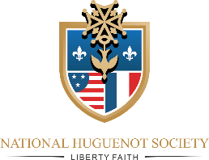
CALL TO THE SEMI-ANNUAL MEETING
of
The National Huguenot Society
Washington, D.C., Wednesday - 10 April 2023 – 12:30 PM
The ARMY & NAVY CLUB on Farragut Square 901 17th ST. NW, Washington, DC 20006
John Paul Jones / IWO Jima Room
- 12:30 PM Registration and start of buffet luncheon: All members and their guests are welcome - $60.00/per person.
- 1:30 PM General Council Meeting (General Officers, State Society Presidents; Chairman of Standing Committees).
- 3:00 PM Necrology Service lead by Chaplain General – Rev. Joel Strauch.
- 3:30 PM Board of General Officers (Elected national officers as defined in the NHS Bylaws).
(A Zoom link is available for the general officers not in attendance.)
- 4:30 PM Benediction and Adjournment.
Dress Code: Gentlemen are required to wear a coat and necktie or a suit. Ladies attire should be of comparable degree of formality.
If you park, you will be charged $22. If you are not charged at the garage, you will need to notify the 3rd VP General and remit the parking fee before leaving the property.
REGISTRATION
NAME(S): _______________________________________________________________________
NAME(S): _______________________________________________________________________
STATE(S) _______________________________________________________________________
NUMBER ATTENDING ( @ $60/person): _____________________________________________
TOTAL: $ __________________________________ CHECK NUMBER: ___________________
Please RSVP by 31 March 2024
Mail Registration and check to the NHS Treasure General:
Catherine Paunov, 5134 29th Avenue N, St. Petersburg, FL 33710-2706

